**The Lightning Thief:**

**The Percy Jackson Musical**

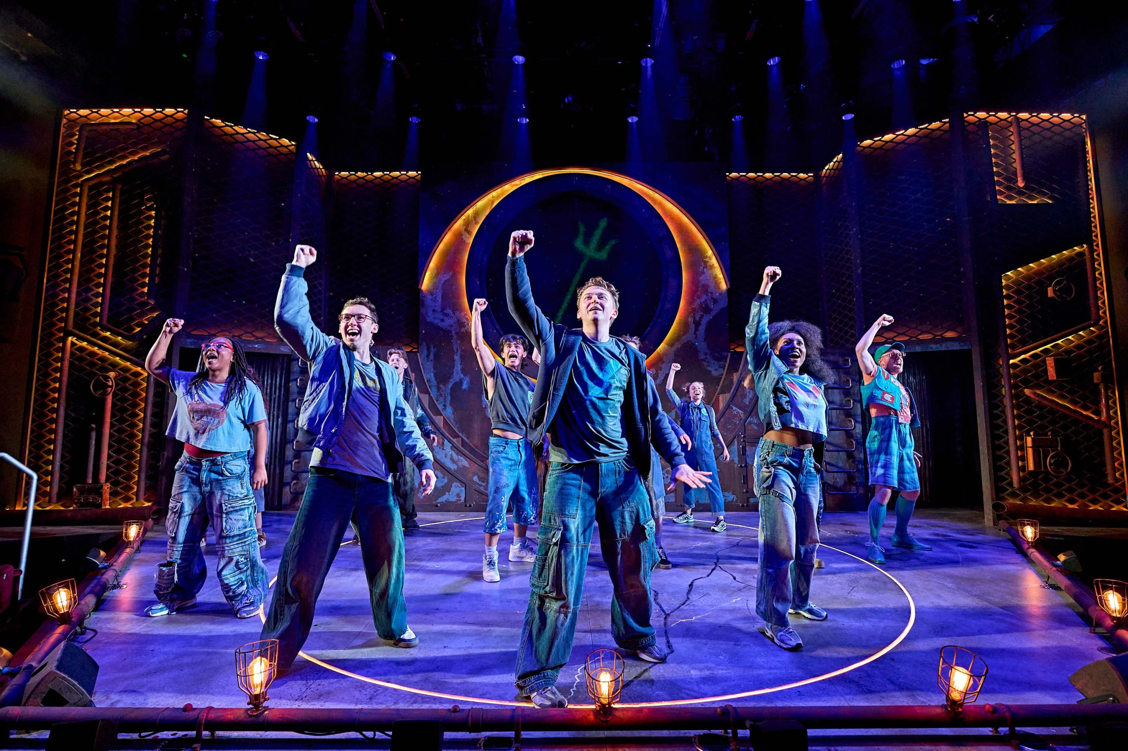

Relaxed Performance Information Pack

**Index**

**Page 3:** Information About The Show

**Pages 4-5:** Information About The Theatre

**Page 6-7:** Characters In The Show

**Page 8:** Things To Look Out For

This guide has been made to help you prepare for your trip to see the relaxed performance of The Lightning Thief: The Percy Jackson Musical with some information about what to expect. We hope you enjoy the performance! If you have any more questions please email [**access@theotherpalace.co.uk**](mailto:access@theotherpalace.co.uk) or call **0207 592 0302**.

A relaxed performance is an adapted version of a show, which allows for a more relaxed environment. The Other Palace is an inclusive venue and wants to ensure that everyone can enjoy the performances on offer.

Typically, in a relaxed performance the following happens:

* The house lights do not go down all the way
* Strobe lighting and pyrotechnics are avoided
* The music and sound are quieter with no sudden loud noises.

Perhaps most importantly it is fine if you make noises or need to stand, move around or take a break at any time. We have a quiet space which will be available 60 minutes before the show, during the interval, and for a short time after the show should you need to take a break.

The Box Office would be happy to create a personalised social story that matches your booking information, just drop us an email at access@theotherpalace.co.uk.

We hope you enjoy the show,

Aimee Smith (Deputy Box Office Manager & Access Lead)

**Information About The Show**

**Length of Show**

The Lightning Thief: The Percy Jackson Musical is 2 hours and 10 minutes long with a 20 minute interval. Each act is 55 minutes long.

**Content Warnings**

This production contains flashing lighting, loud and sudden noises, smoke effects, mild threat…and mythical creatures!

**What Will Be Different**

* You are welcome to make noise, move around in your seat and leave the auditorium when you need to.
* The sound will be a lot quieter than usual, and any strobe will be removed. The flashing lights will be turned down so they are not as bright.
* The auditorium lights will not go all the way down, so it won’t be as dark.

It is okay if you need to leave the auditorium at any point, you can leave and come back in whenever you need to. We have a quiet space upstairs if you need to take a break, but we don’t have screens to watch the show on from outside.

**What Is The Show About**

When New York City teenager Percy Jackson discovers that he is the half-blood son of the Greek god, Poseidon, his life takes a dramatic turn as he is plunged into a world much bigger than he could possibly have imagined.

With newly discovered powers he is unable to control, an unwanted destiny and a whole textbook’s worth of mythical monsters on his trail, Percy must learn what it means to be a hero.

**Information About The Theatre**

The main entrance brings you straight into our Foyer, where you will be helped by a member of our team. You will see the Box Office and Merchandise desk straight ahead as you come in. You will also see the accessible toilet.

**When You Arrive**

* We will say hello and welcome you to the venue
* A bag search where we will check to see if you have any glass or anything sharp with you. However, nothing will be taken from you unless it is sharp/dangerous, alcoholic or hot food. We will also not take medicines away from you.
* If you arrive early, you might have to wait in the foyer for the auditorium to open. This might be busy and noisy so if it’s easier, you are welcome to wait outside the theatre or in our quiet space.

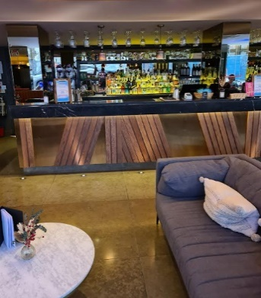What’s At The Other Palace**

Bar

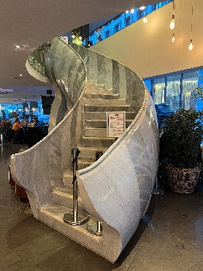

Quiet Space

Box Office

**Toilets**

There are a few different sets of toilets at The Other Palace.

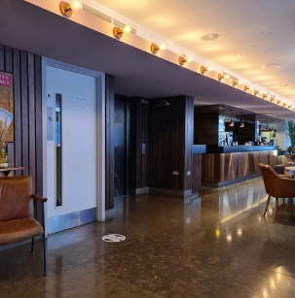

These are the main toilets in the foyer. They are the first white door on the left when you arrive.

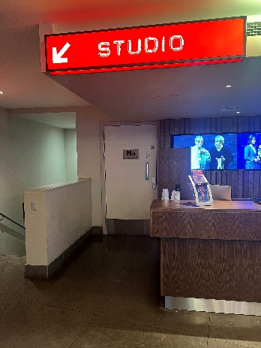

This is the accessible toilet in the foyer. It is straight ahead of you to the left of the Box Office when you arrive. It needs a radar key, but if you forget yours the Box Office can let you in.

You can find the toilets inside the auditorium through this door on the left hand side. Follow the signs and you will find the toilets.

Our toilets have hand driers which might be a little bit noisy. We do not have an adult changing table or a hoist.

**Entering The Auditorium**

Once the doors to the auditorium open, you can join the queue and one of our Ushers will scan your ticket. You can then go inside and find your seat. There is no bar or merchandise inside so if you would like to buy anything you will have to come back out to the foyer. Merchandise will be sold before the show, in the interval and briefly after the show.

If you find it tricky to wait to get into the auditorium, please speak to a member of staff (who will be wearing a t-shirt or lanyard with our logo on) who will help you enter the auditorium faster.

**Assisted Listening**

The Other Palace uses the**Sennheiser Mobile Connect** app for assisted listening options. If you would like to use the system and your hearing aids connect to your iPhone via Bluetooth, once you have the app you are ready to go! If your hearing aids do not connect via Bluetooth, or you have an Android phone, please bring a pair of headphones with you (over-ear wired headphones are best), or if you are unable please enquire at the Box Office about hiring a pair for the duration of the performance.

Please ensure that your smart device is fully charged, and you arrive with plenty of time to get the connection instructions from the Box Office. The system will work in all areas of the Main House.

**Characters In The Show**

This is Morgan. He plays ‘Percy Jackson’ throughout the show.



This is Angus. He plays ‘Grover’ throughout the show.



This is Lizzy-Rose. She plays ‘Annabeth’ throughout the show.



This is Xander. He mostly plays ‘Luke’ but plays one other character during the show.



This is Vicki. She plays ‘Sally Jackson’ (Percy’s Mum) as well as few other characters and wears lots of different costumes.



This is Jazz. He plays Percy’s teacher ‘Mr Bruner’ as well as few other characters and wears lots of different costumes.

This is Kenedy. She plays ‘Clarisse’ as well as few other characters and wears lots of different costumes.



This is Joshua. He plays ‘Mr D’ as well as few other characters and wears lots of different costumes.

This is Philip. He is in the ensemble, and will cover another actor if they are unwell or unable to perform.

This is Alex. She is in the ensemble, and will cover another actor if they are unwell or unable to perform.



This is Rachel. She is in the ensemble, and will cover another actor if they are unwell or unable to perform.



This is Owen. He is in the ensemble, and will cover another actor if they are unwell or unable to perform.



This is Greg. He is in the ensemble, and will cover another actor if they are unwell or unable to perform.

**Things To Look Out For**

**Throughout The Show**

* The main lights will not go down all the way, so that you can see your way out if you need to leave.
* Although the sound has been turned down, it may still be a little bit loud so you may want to bring ear defenders if you need to. If you forget your ear defenders, the Box Office have some that you could borrow, as well as some ear plugs.
* Although the strobe lighting has been removed and the flashing lights have been turned down, it may still be a little bit bright sometimes. You are welcome to cover your eyes, or leave at any point if it still feels too flashy.
* There are a few times in the show where the characters have fights and use swords. The actors have practiced the fight lots of times, so they know what to do to keep themselves safe.
* Sometimes there will be haze on stage which makes it look a bit foggy, this is made of water and is safe to breathe.

**Moments To Watch Out For**

* After the song ‘Strong’ in act one, we will see a mythical creature called a Minotaur. It is made out of cages and the actors help to make it look real. Here is a photo of it.

This might be a little bit scary, but remember it is all acting and everyone is safe on stage.

* At the end of the song ‘Another Terrible Day’ in act one, Mr D will throw a cup of confetti into the lap of someone sat in the front row.
* Grover and Mr Bruner’s legs might look different at different points during the show. Sometimes they will look like human legs, and sometimes they will look like animal legs.
* During the campfire song, there will be a real fire in a barrel on stage. Don’t worry, it is being watched carefully to make sure everyone is safe.
* During act two, there are torches used on stage. The actors will try to avoid shining them into the audience.
* During act two, a trick happens with a character called Medusa’s head. It will look scary, and like she’s hurt, but it’s just magic and acting and she’s really safe and sound.